ADVANCED VULNERABILITY ASSESSMENT & PENETRATION TESTING (VAPT) REPORT

Intern Name : PERARASU M
Domain : Cyber Security / VAPT
Organization : Cyart Tech
Assessment Period : 15th Jan 2026
Submission Date : 16th Jan 2026

Target : Metasploitable 2
Assessment Type : Advanced VAPT
Methodology : PTES
Authorization : Lab-based

1. Introduction
This report documents the Week 3 activities of the Vulnerability Assessment and Penetration Testing (VAPT) internship. The focus of this week is on advanced exploitation concepts, web application penetration testing, exploit chaining, post-exploitation understanding, and professional reporting aligned with PTES methodology.
All activities were conducted in a controlled lab environment using intentionally vulnerable systems.

2. Scope & Methodology

2.1 Scope
- Target System: Metasploitable 2
- Web Application: Mutillidae
- Assessment Type: Advanced VAPT (Lab-Based)
- Authorization: Approved vulnerable lab environment

2.2 Methodology
The assessment follows the Penetration Testing Execution Standard (PTES):
- Planning & Scoping
- Reconnaissance
- Vulnerability Scanning
- Exploitation
- Post-Exploitation
- Reporting

3. Theoretical Background

3.1 Advanced Vulnerability Exploitation
Advanced exploitation involves chaining multiple vulnerabilities to increase attack impact. An exploit chain may combine client-side and server-side vulnerabilities, such as XSS leading to session hijacking and further system compromise. Exploit customization involves modifying existing Proof-of-Concept scripts to match specific environments. Obfuscation techniques such as encoding and payload modification help bypass basic security defenses.

3.2 Web Application Penetration Testing
Web application penetration testing focuses on identifying vulnerabilities listed in the OWASP Top 10, such as SQL Injection, Cross-Site Scripting, insecure design, and authentication failures. Both manual testing using tools like Burp Suite and automated testing using sqlmap are essential to identify and validate vulnerabilities accurately.

3.3 Reporting & Stakeholder Communication
Effective reporting ensures that findings are clearly communicated to both technical and non-technical stakeholders. Technical reports contain exploit details and remediation steps, while non-technical summaries focus on business impact and risk.

4. Environment Setup
- Attacker Machine: Kali Linux
- Target Machine: Metasploitable 2
- Network Configuration: VMware Host -Only Network

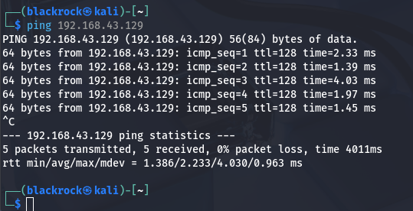

5. Reconnaissance Phase
Initial reconnaissance was performed to identify exposed services and applications on the target system. Service enumeration revealed multiple open ports and web applications hosted on the target.

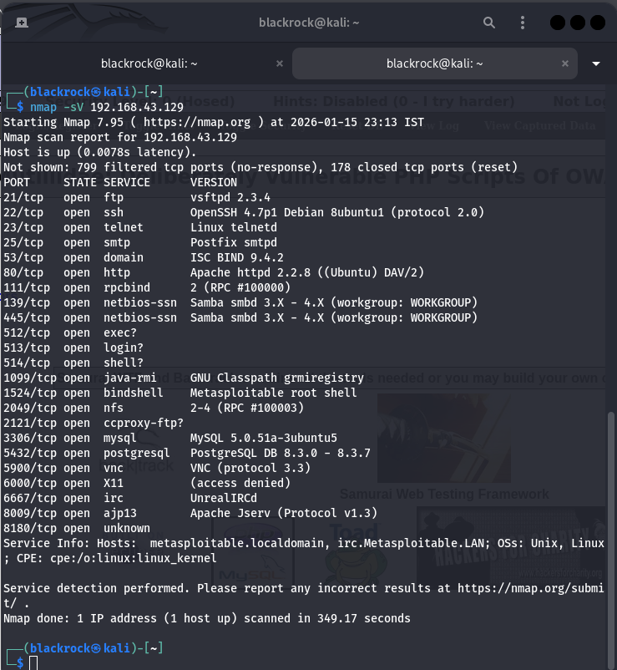
Reconnaissance Summary (50 Words)
Reconnaissance activities on the Metasploitable lab machine identified multiple exposed services and vulnerable web applications. Service enumeration revealed insecure configurations commonly found in vulnerable environments. These findings provided a foundation for targeted vulnerability scanning and exploitation during subsequent assessment phases.

6. Web Application Penetration Testing

6.1 Target Application

- Application: Mutillidae
- Vulnerable Page: SQLi – Extract Data (User Info Page)

6.2 SQL Injection – Authentication Bypass

URL:
http://192.168.43.129/mutillidae/index.php?page=user-info.php
Vulnerability Type: SQL Injection (Authentication Bypass)
Severity: Critical
Description:
The login functionality does not properly sanitize user-supplied input. By injecting SQL payloads into the username and password fields, authentication checks can be bypassed, allowing unauthorized access to sensitive user information stored in the backend database.
Manual Payload Used:
Username: ' OR '1'='1
Password: ' OR '1'='1
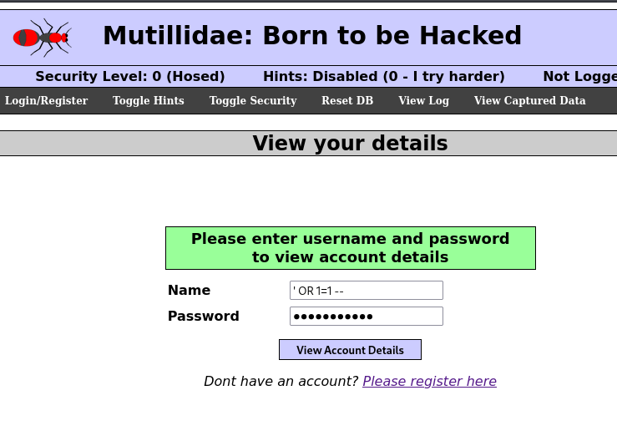

6.3 Automated Validation (sqlmap)
sqlmap was used to validate the SQL Injection vulnerability and enumerate available databases.
Command used:
sqlmap -u "http://<target_ip>/mutillidae/index.php?page=user-info.php" \
--data="username=test&password=test&login=Login" --dbs

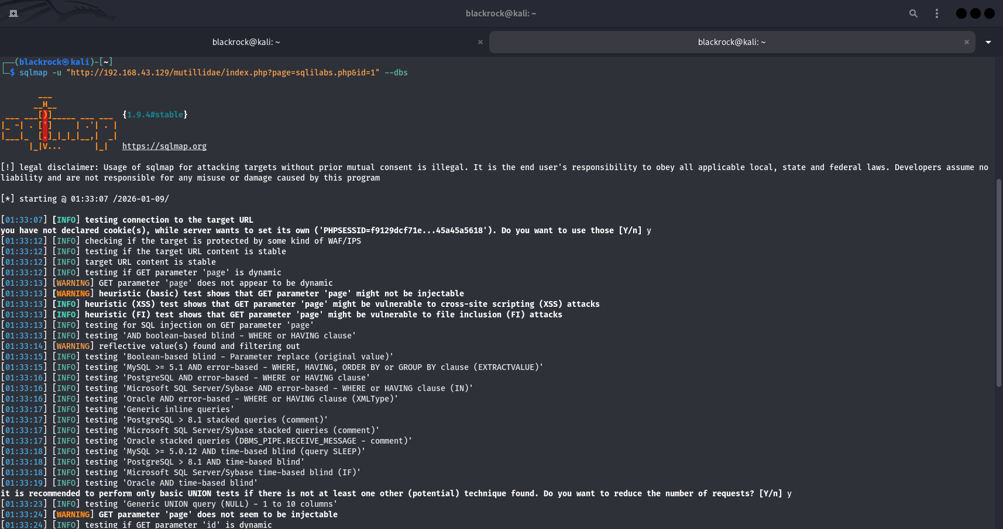
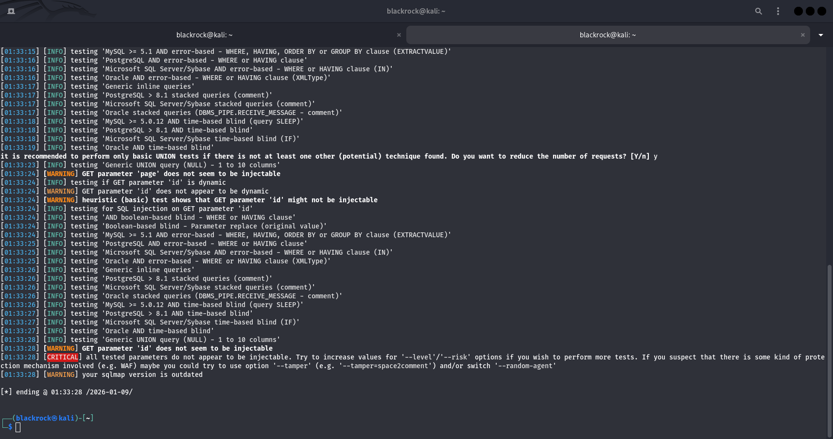

6.4 Web Testing Log
Test ID | Vulnerability | Severity | Target URL
001 | SQL Injection (Auth Bypass) | Critical | Mutillidae – User Info Page

7. Advanced Exploitation (Exploit Chain Simulation)

7.1 Exploit Chain Description
An exploit chain was simulated to demonstrate how multiple vulnerabilities can be combined to increase attack impact.

Exploit Chain Flow:

SQL Injection (Auth Bypass)
↓
Unauthorized Access to User Data
↓
Session Manipulation / Privilege Abuse
↓
Remote Code Execution (Conceptual)
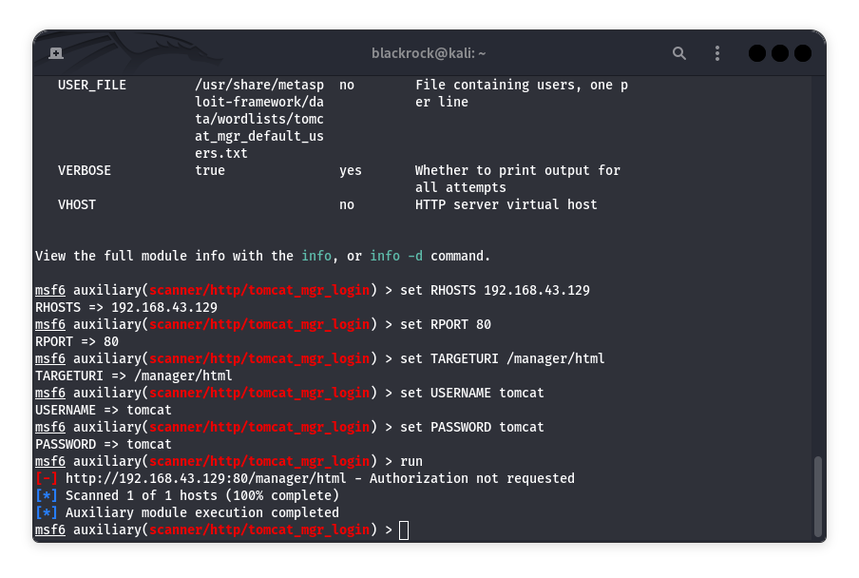

7.2 Exploit Chain Log
Exploit ID | Description | Target IP | Status | Payload
001 | SQLi to RCE Chain | 192.168.43.129 | Simulated | Meterpreter

7.3 Exploit-DB Validation Summary (50 Words)
Public Proof-of-Concept references from Exploit-DB confirm that SQL Injection vulnerabilities can be chained with other weaknesses to achieve deeper system compromise. These PoCs demonstrate how improper input handling can escalate from authentication bypass to full system control when combined with misconfigurations.

8. Post-Exploitation & Evidence Collection

8.1 Post-Exploitation Analysis
Post-exploitation techniques were reviewed; however, full execution was not applicable due to the absence of an active shell session. This limitation highlights the dependency of post-exploitation activities on successful exploitation and target compatibility.

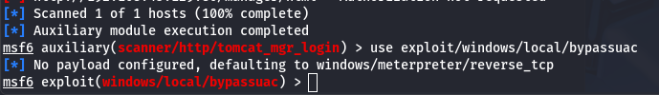

8.2 Evidence Collection
Item | Description | Collected By | Date | Hash Value
Traffic Log | HTTP Traffic | VAPT Analyst | 2025-01-15 | <SHA256>

Evidence Summary (50 Words)
Collected evidence was handled following chain-of-custody principles. Hashing was used to ensure integrity and authenticity of captured data. Proper evidence handling ensures findings remain verifiable and defensible during security assessments.

9. Capstone – Full VAPT Cycle

9.1 Vulnerability Detection Log
Timestamp | Target IP | Vulnerability | PTES Phase
2025-01-15 13:45:34 | 192.168.43.129 | SQL Injection | Exploitation

9.2 Remediation Recommendations
- Use prepared statements and parameterized queries
- Implement strict server-side input validation
- Secure authentication mechanisms
- Apply least-privilege access controls
- Patch web server and application components
- Perform re-scanning after remediation

10. Technical PTES Report (200 Words)
This advanced penetration testing exercise was conducted on an intentionally vulnerable lab environment following the PTES methodology. Reconnaissance and scanning phases identified exposed services and vulnerable web applications. Manual and automated testing revealed a critical SQL Injection vulnerability in the Mutillidae application, allowing authentication bypass and unauthorized data access.
An exploit chain was simulated to demonstrate how SQL Injection can be combined with session manipulation and misconfigurations to achieve deeper system compromise. Although full post-exploitation was limited by lab constraints, the findings clearly illustrate real-world attack paths.
Remediation measures were recommended to mitigate identified risks, including secure coding practices and re-testing. This assessment reinforces the importance of layered defenses, structured testing methodologies, and accurate reporting in advanced security engagements.

11. Non-Technical Summary (100 Words)
This security assessment identified serious weaknesses in a test system that could allow attackers to access sensitive information without authorization. A critical vulnerability was found in a web application login function due to improper input handling. If exploited in a real environment, such weaknesses could lead to data breaches and operational disruption. Applying secure development practices and regular security testing will significantly reduce risk and strengthen the overall security posture.

12. Key Learnings
- Gained hands-on experience in advanced web application penetration testing using intentionally vulnerable lab environments.
- Developed a strong understanding of SQL Injection vulnerabilities, including authentication bypass and data extraction techniques.
- Learned how individual vulnerabilities can be logically chained to simulate advanced exploitation scenarios.
- Understood the importance of manual testing in identifying issues that automated tools may not fully reveal.
- Improved knowledge of PTES methodology and its application in real-world penetration testing workflows.
- Enhanced skills in professional vulnerability reporting and stakeholder communication.

13. Challenges Faced
- Some exploitation techniques could not be fully executed due to limitations of the lab environment and target configuration.
- Automated tools such as sqlmap occasionally required manual intervention and fine-tuning to work correctly with the application.
- Post-exploitation activities were limited due to the absence of an active shell session, highlighting real-world constraints during assessments.
- Understanding and documenting exploit chaining required careful analysis to avoid false assumptions or unrealistic claims.
- Managing and organizing screenshots and evidence for proper reporting required additional attention to detail.

14. Conclusion
The Week 3 VAPT activities successfully demonstrated advanced vulnerability exploitation concepts, web application testing, exploit chaining, and professional reporting. This exercise strengthened both technical skills and analytical thinking required for real-world penetration testing engagements.

